# An Investigation into Experience Driven Procedural Music Generation

Please take your time to read the following information carefully and feel free to ask me any questions. The survey and the game should take no longer than 20 minutes to complete altogether.

Aim of Research:

This questionnaire is part of the evaluation section of the researcher’s CMP404 Honours Project Execution Module at Abertay University.

The aim of this survey is to evaluate how well experience driven procedural content generation works for music in games.

Content of the Questionnaire:

This survey will evaluate your previous experience with music and video game, and you well you think the music generation works. You will then be asked to play the game before continuing with the questionnaire.

Data Protection:

All the data recorded from this survey will be made anonymous. The researcher will do their best to not collect any identifiable data. The data will not be accessible by anyone other than the researcher and the researcher’s project supervisor and will be stored on the researcher’s password protected hard drive. A summary of results will be presented in the researcher's dissertation but no data that can be directly linked to you. The anonymised data will be kept until the study has been completed and the data will be destroyed on or before the 10th May 2019.

## Consent From

|  |  |
| --- | --- |
|  | Tick box to agree |
| I confirm I am 18 years old or older |  |
| I understand that I can withdraw from the project at any time before submitting the survey without having to provide a reason |  |
| I understand that the data I submit as part of this survey is stored anonymously |  |
| I understand and consent to how my data is processed and stored |  |
| I consent to participating in this survey as part of the study |  |

Contact information:

If you would like further information on this study or have questions regarding the survey please contact the researcher, Andrew Milne, by email at [1101624@abertay.ac.uk](mailto:1101624@abertay.ac.uk).  
You can contact the researcher’s supervisor, Grant Clarke, by email at   
[g.clark@abertay.ac.uk](mailto:g.clark@abertay.ac.uk).

The Research Ethics Committee, University of Abertay, has reviewed and approved this research study. If you have any ethical concerns or complaints about the conduct of this research, please contact the committee at [ResearchEthics@abertay.ac.uk](mailto:ResearchEthics@abertay.ac.uk).

## Previous Experience

### In a typical week, how often do you play games?

|  |  |  |  |  |
| --- | --- | --- | --- | --- |
| Never | < 30 mins | < 2 hrs | < 5hrs | > 5 hrs |

### Do you play a musical intrument?

Yes/no

### Reactive music is when the actions of in-game characters and/or events affect the game's music. How important do you think this is?

|  |  |  |  |  |
| --- | --- | --- | --- | --- |
| 1 (Not important) | 2 | 3 | 4 | 5 (Very important) |

## Before playing the game.

During the game look out for this type of lights, they will change colour as you progress.

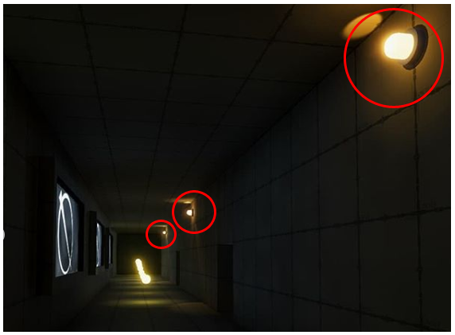

Please now play the game before moving onto the next questions, pay attention to the music as you play

You can download the game here:

https://drive.google.com/open?id=11EqjHliXnR3_lOL9w_OrduV7ucdO7gcH

Note, you do not need to complete the game, getting to around 150 points will be sufficient

### How to play the game

Double click the file called HonoursGame.exe

This should take you to the main menu

Clicking quit will quit the game

Clicking play will launch the game

WASD to move your character

Mouse to look around

Left shift to run

Try to collect all 200 pellets without getting caught by the guards.

## How would you describe the music at these points in the game?

### At the start

|  |  |  |  |  |  |  |
| --- | --- | --- | --- | --- | --- | --- |
| Exciting | Stressful | Happy | Sad | Relaxed | Boring | Other |

(Optional) If other, how would you describe it?

_________________________________________

### When the lights change to orange

|  |  |  |  |  |  |  |
| --- | --- | --- | --- | --- | --- | --- |
| Exciting | Stressful | Happy | Sad | Relaxed | Boring | Other |

(Optional) If other, how would you describe it?

_________________________________________

### When the lights change to red

|  |  |  |  |  |  |  |
| --- | --- | --- | --- | --- | --- | --- |
| Exciting | Stressful | Happy | Sad | Relaxed | Boring | Other |

(Optional) If other, how would you describe it?

_________________________________________

### When being chased by the guards

|  |  |  |  |  |  |  |
| --- | --- | --- | --- | --- | --- | --- |
| Exciting | Stressful | Happy | Sad | Relaxed | Boring | Other |

(Optional) If other, how would you describe it?

_________________________________________

## You will now have to answer 9 questions, you will be told about an event that can occur in the game and asked if this event had any effect on the music. You can also say what effect you think this had.

### Did this event effect the music?

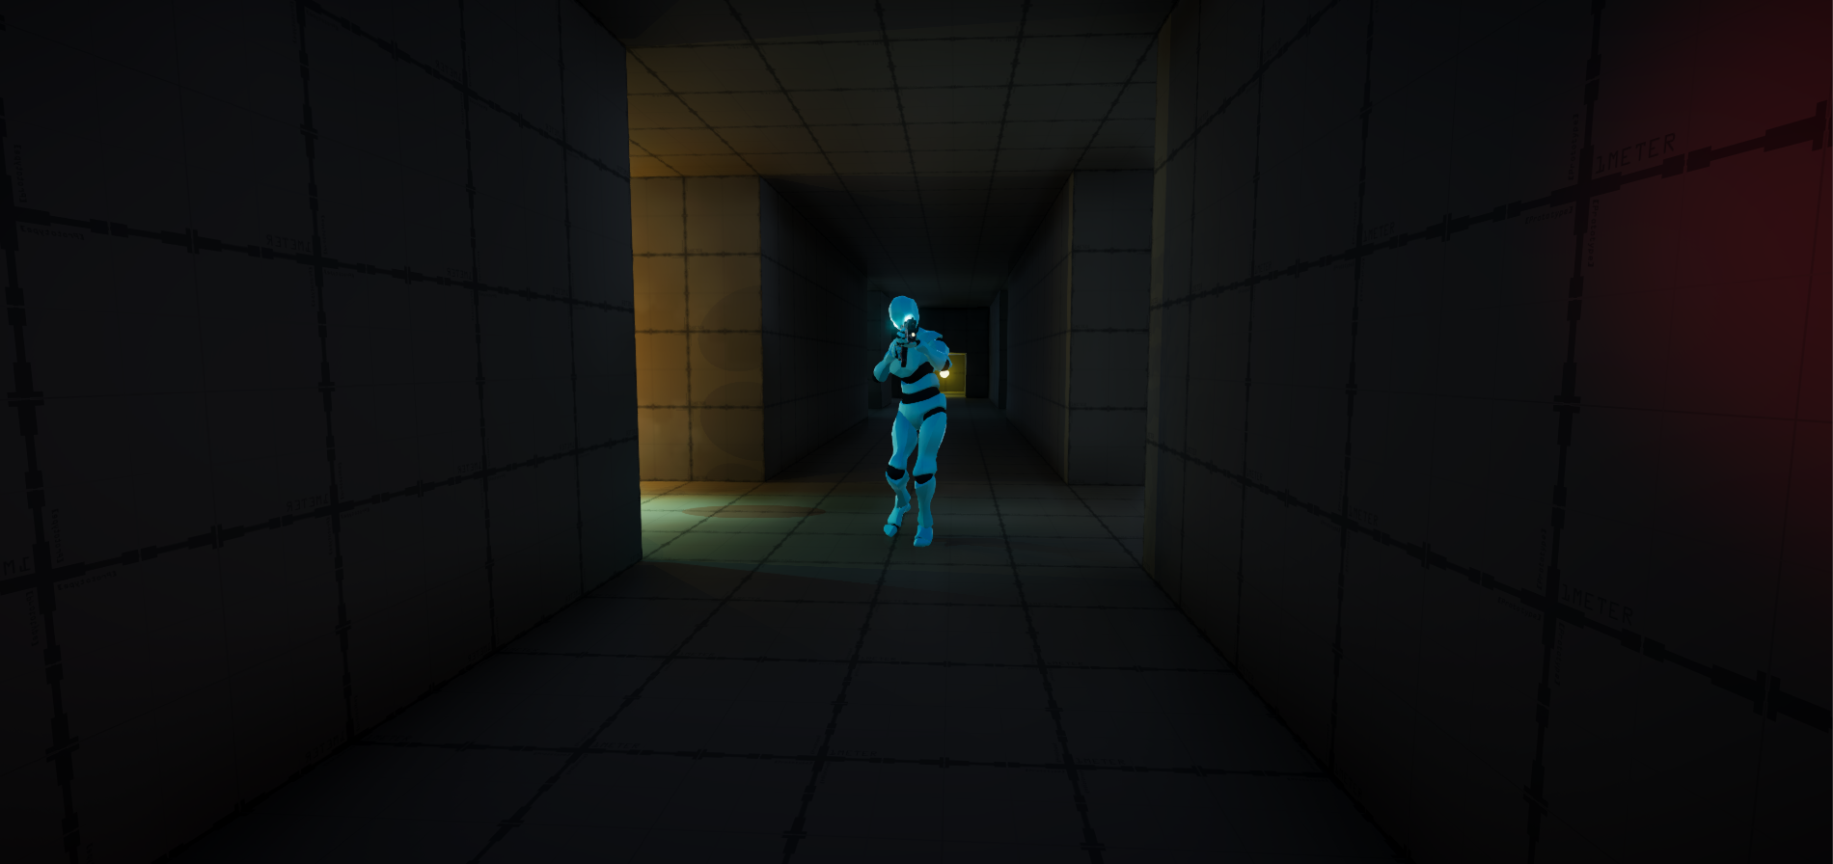

If a guard has seen you

|  |  |  |
| --- | --- | --- |
| Yes | No | Not Sure |

(Optional) If yes, how did this affect the music?

________________________________________________________

### Did this event effect the music?

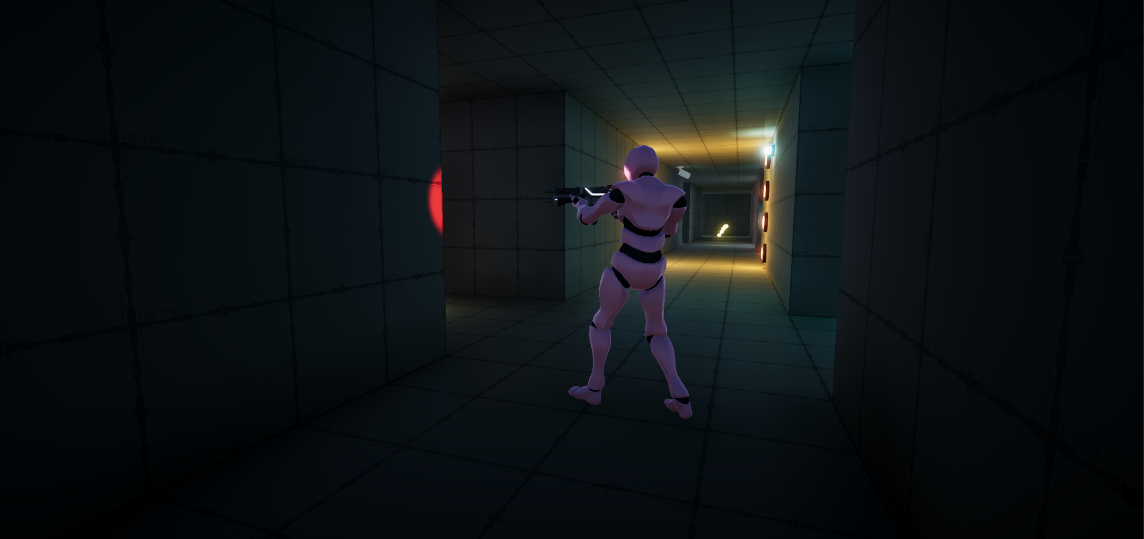

Being close to a guard

|  |  |  |
| --- | --- | --- |
| Yes | No | Not Sure |

(Optional) If yes, how did this affect the music?

________________________________________________________

### Did this event effect the music?

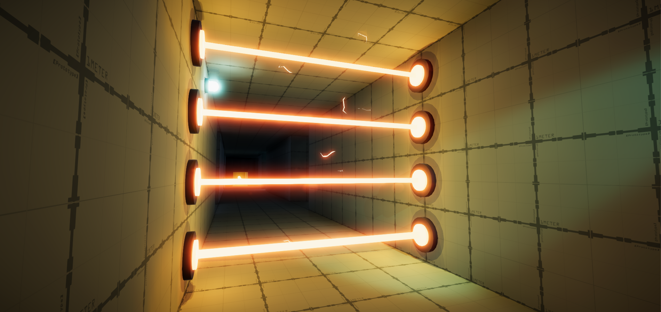

Being close to the laser grids

|  |  |  |
| --- | --- | --- |
| Yes | No | Not Sure |

(Optional) If yes, how did this affect the music?

________________________________________________________

### Did this event effect the music?

How high your score is

|  |  |  |
| --- | --- | --- |
| Yes | No | Not Sure |

(Optional) If yes, how did this affect the music?

________________________________________________________

### Did this event effect the music?

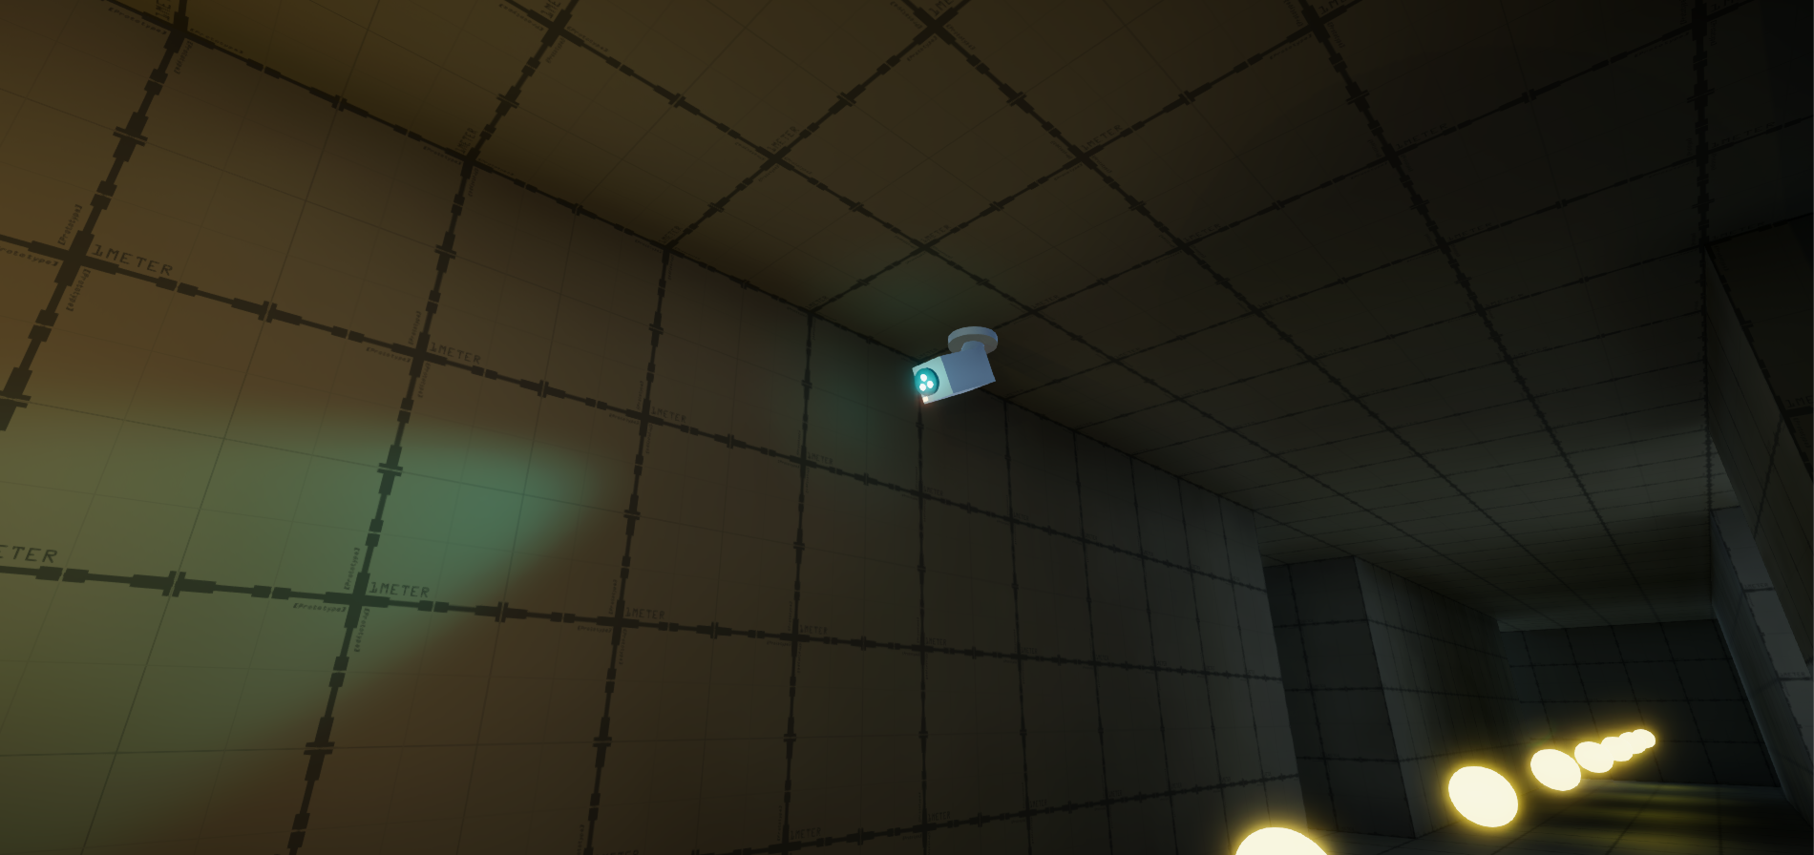

If a security camera has seen you

|  |  |  |
| --- | --- | --- |
| Yes | No | Not Sure |

(Optional) If yes, how did this affect the music?

________________________________________________________

### Did this event effect the music?

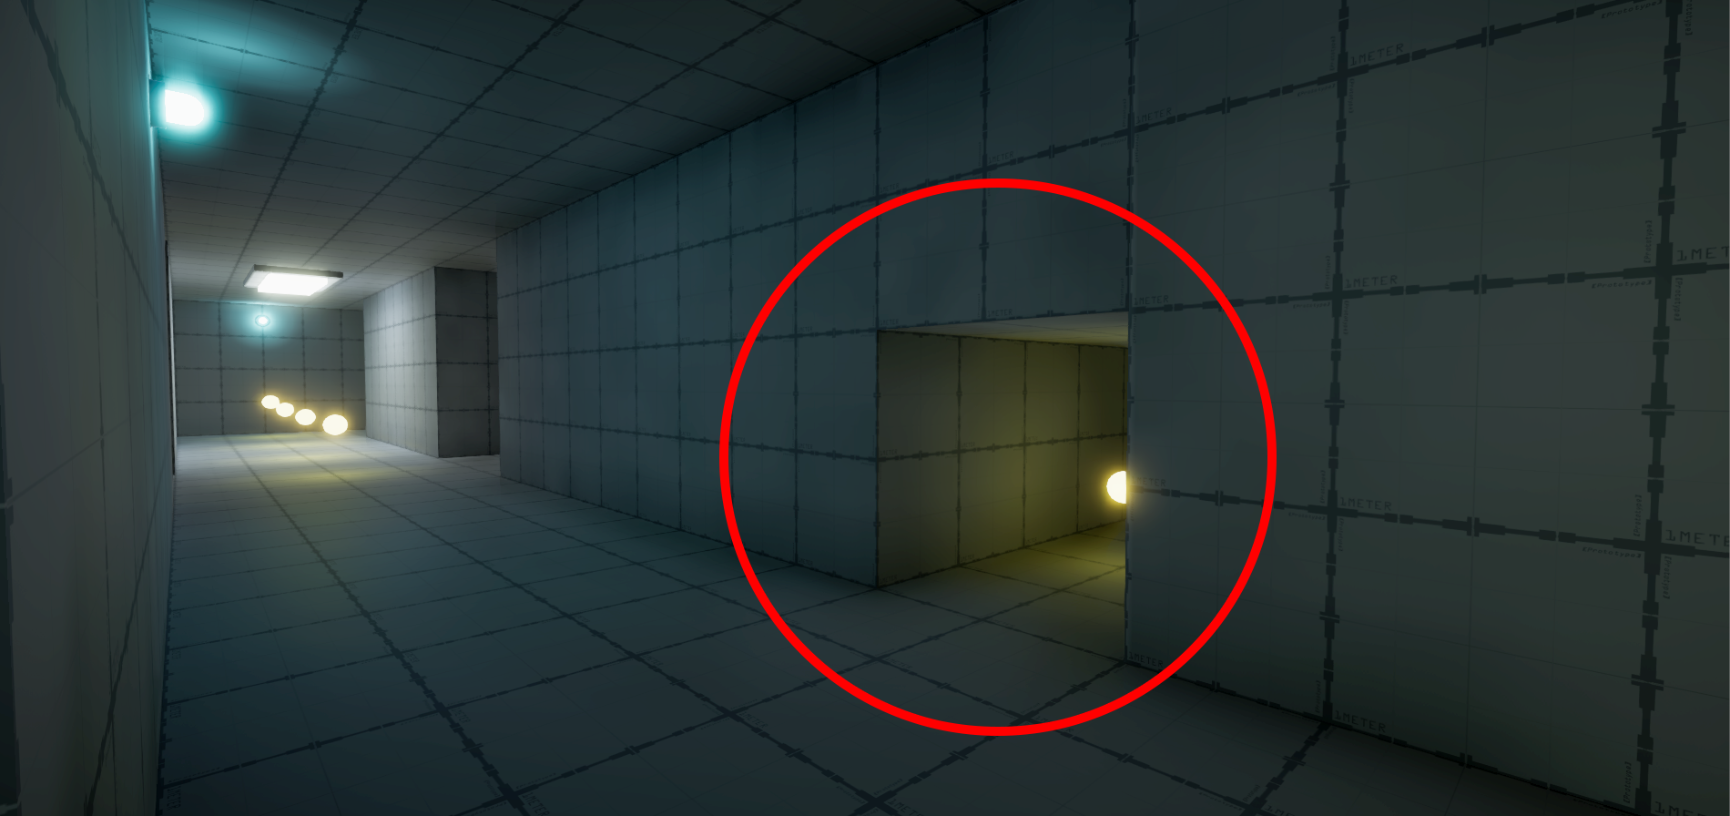

Being inside a secret passage

|  |  |  |
| --- | --- | --- |
| Yes | No | Not Sure |

(Optional) If yes, how did this affect the music?

________________________________________________________

### Did this event effect the music?

How fast you are moving

|  |  |  |
| --- | --- | --- |
| Yes | No | Not Sure |

(Optional) If yes, how did this affect the music?

________________________________________________________

### Did this event effect the music?

How many lives you have left

|  |  |  |
| --- | --- | --- |
| Yes | No | Not Sure |

(Optional) If yes, how did this affect the music?

________________________________________________________

### Did this event effect the music?



Using the teleporters

|  |  |  |
| --- | --- | --- |
| Yes | No | Not Sure |

(Optional) If yes, how did this affect the music?

________________________________________________________

## Thoughts on the project

### (Optional) Do you have any feedback on the music present in the game?

_______________________________________________

### (Optional) Do you have any feedback on the game itself?

_______________________________________________